Date: 13-02-19
Daily Report on WIT & WIL
Name of the faculty : B.V.Kiranmayee Name of the subject : Programming through C
Class/ Section : I B.Tech II sem CSE – A
1 | Grid Reference No : | 2.2
2 | Scenario Reference: | 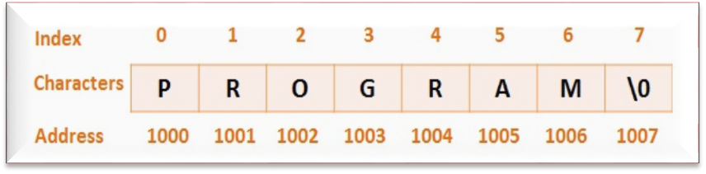  Collection of Characters- Strings  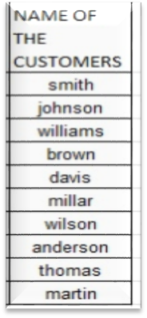  Customer Names by Strings
3 | Topic Covered: | 2D Strings
4 | DECLARATION AND INITIALIZATION OF A 2D CHARACTER ARRAY  A 2D character array is declared in the following manner:  char name[5][10];  2D CHARACTER ARRAY-STRING ARRAY-DECLARATION AND INITIALIZATION  We have successfully learned the basic concepts and different library functions that C Programming offers. Another interesting concept is the use of 2D character arrays. In the previous tutorial, we already saw that string is nothing but an array of characters which ends with a ‘\0’. 2D character arrays are very similar to the 2D integer arrays. We store the elements and perform other operations in a similar manner. A 2D character array is more like a String array. It allows us to store multiple strings under the same name.  Table of Contents  - Declaration and Initialization of a 2D character array  - Taking Data input from user  - Printing the array elements  - Program to search for a string in the string array  - Recommended -  DECLARATION AND INITIALIZATION OF A 2D CHARACTER ARRAY  A 2D character array is declared in the following manner:  char name[5][10];  The order of the subscripts is to kept in mind during declaration. The first subscript [5] represents the number of Strings that we want our array to contain and the second subscript [10] represents the length of each String.This is static memory allocation. We are giving 5*10=50 memory locations for the array elements to be stored in the array.  Initialization of the character array occurs in this manner:  see the diagram below to understand how the elements are stored in the memory location: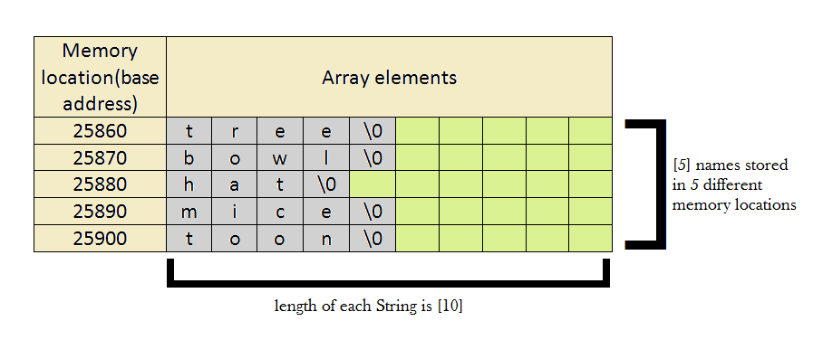  PROGRAM TO SEARCH FOR A STRING IN THE STRING ARRAY  #include <stdio.h>  #include <string.h>  int main()  {  char name[5][10],item[10];//declaring the string array and the character array that will contain the string to be matched  int i,x,f=0;  /*taking 5 string inputs*/  printf("Enter 5 strings:\n");  for(i=0 ;i<5 ;i++ )  scanf("%s",&name[i][0]);  /*entering the item to be found in the string array*/  printf("Enter the string to be searched:\n");  scanf("%s",&item);  /*process for finding the item in the string array*/  for(i=0; i<5 ;i++ ){  x=strcmp(&name[i][0],item);//compares the string in the array with the item and if match is found returns 0 and stores it in variable x  if(x == 0)  f=i;  }  /*if match is not found*/  if(f==0)  printf("the item does not match any name in the list");  /*If the match is found*/  else  printf("Item Found. Item in the array exists at index - %d", f);  return 0;  }
  1  2  3  4  5  6  7 | char name[5][10]={  "tree",  "bowl",  "hat",  "mice",  "toon"  };
5 | Relevant additional illustration if any : Searching Contacts in the Mobile phone
6 | Video links / web links if any: | https://www.youtube.com/watch?v=m9CS5W561pU
7 | Signature of Repository Administrator:

